**DAR ES SALAAM INSTITUTE OF TECHNOLOGY**



**BACHELOR OF ELECTRONICS AND TELECOMMUNICATIONS ENGINEERING**

**NTA LEVEL 8**

**SENIOR PROJECT 1**

**PROJECT TITLE: AI BASED CAR ACCIDENT DETECTION AND RESCUER ALERT TO NEARBY HOSPITAL**

**PROJECT TYPE: PROBLEM SOLVING**

**STUDENT NAME: VICTOR A. MAGAYANE**

**REGISTRATION NO: 190630722014**

**CLASS: BENG 19 ETE**

**SUPERVISOR’S NAME: DR. JORDAN HOSSEA**

**FEBRUARY 2023**

DECLARATION

I, VICTOR A. MAGAYANE **,** student of Bachelor of Engineering in Electronics and Telecommunications Engineering with registration number 190630722014 **,** declare to the best of my knowledge that, the project presented here as partial fulfilment of bachelor’s degree of Engineering in Electronics and Telecommunications, is my original work and has not been copied or presented elsewhere, except where explicitly indicated as reference have been dully acknowledged.

Name: VICTOR A. MAGAYANE

Signature: ………………………….

Date: ……………………………….

CERTIFICATION

As the candidate’s supervisor, I have approved this project report for submission.

SUPERVISOR’S NAME: ………………………….

SIGNATURE: ………………………….

DATE: ……………………………….

ACKNOWLEDGMENT

First of all, I would like to thank Almighty God for his showers of blessings throughout my Institute life from when I stepped at DIT to this point. I further extend my gratitude to my DIT family including lectures, technicians and classmates for the cooperation and the knowledge I have acquire from them that pushed me to come with this project idea.

I would like to express my sincere gratitude to my supervisor Dr. JORDAN HOSSEA for intensive guidance, information, motivation and unending support up to this stage of my project conceptualization. Nevertheless, many thanks should go directly to the project coordinator, Dr. MKIRAWENI for giving me the key points on how to prepare good project.

Finally, I would like to show my appreciations to Department of Electronics and Telecommunication and fellow students for their best efforts, guidance and motivation towards pushing this project forward.

ABSTRACT

This report proposes a system that will alert a nearby hospital about an accident whenever it occurs. This system is Artificial Intelligent (AI) based, it will sense various input parameters from the vehicle in real time and regarding the information stored in the trained model, it will evaluate if there is an accident or not. accident, If the accident is detected by the model, then the notification alert will be popped up to the website of the nearby hospital. If no accident detected by the model the action will be ignored. At the same time if the accident occur the website application will send automatic SMS to the register numbers of responsible close relative which will show the location where accident occur and the hospital where the patient will be sent together with a link so the he/she can login to the website to see more details.

To accomplish the aim of this project a number of literature reviews have been read, primary data have been collected to confirm the need of the proposed system and secondary data have been collected to evaluate the technical requirements of the proposed system.

TABLE OF CONTENTS

DECLARATION i

CERTIFICATION ii

ACKNOWLEDGMENT iii

ABSTRACT iv

TABLE OF CONTENTS v

LIST OF FIGURES ix

LIST OF TABLES x

LIST OF ABBREVIATION xi

CHAPTER ONE 1

1 INTRODUCTON 1

1.1 General introduction 1

1.2 Background information 1

1.3 Problem statement 2

1.4 Objectives of the project 2

1.4.1 Main objective 2

1.4.2 Specific objectives 2

1.5 Methodology 3

1.5.1 Literature review 3

1.5.2 Data collection 3

1.5.3 Data analysis 3

1.5.4 Circuit design 3

1.5.5 Circuit implementation and testing 3

1.5.6 Report writing 3

1.6 Significance of the project 4

1.7 Chapter conclusion 4

CHAPTER TWO 5

2 LITERATURE REVIEW 5

2.1 Introduction 5

2.2 Phone calls from victims or good Samaritan 5

2.3 GPS Location tracking system 6

2.4 How the system works 6

2.5 Road Accident Information System (RAIS) 6

2.5.1 Advantages of RAIS 7

2.6 EXISTING SYSTEM 8

2.6.1 Functionality of the system. 8

2.6.2 Advantages 9

2.6.3 Disadvantages 9

2.7 Chapter summary 9

CHAPTER THREE 10

3 PROPOSED SYSTEM 10

3.1 Introduction 10

3.2 Block diagram of proposed system 10

3.3 Functionality of the proposed system. 11

3.4 Parts of the proposed system. 12

3.4.1 Power supply 12

3.4.2 Flame Sensor 12

3.4.3 Smoke sensor 12

3.4.4 Vibration sensor 12

3.4.5 Gyroscopic sensor 12

3.4.6 Rapid brake sensor 12

3.4.7 Button 12

3.4.8 Control unit 12

3.4.9 Communication module 13

3.4.10 Trained model 13

3.4.11 Website system 13

3.4.12 IoT 13

3.5 Chapter summary 13

CHAPTER FOUR 14

4 DATA COLLECTION 14

4.1 Introduction 14

4.2 Primary data 14

4.3 Secondary data. 16

4.3.1 Power supply 16

4.3.2 Control unit. 17

4.3.3 GPS Module 18

4.3.4 Flame sensor 18

4.3.5 Smoke detector 18

4.3.6 Vibration sensor 19

4.3.7 Gyroscopic sensor 19

4.3.8 Rapid brake sensor 20

4.3.9 Push button. 20

4.3.10 Website and DBMS unit 21

4.4 Chapter summary. 22

CHAPTER FIVE 23

5 CONCLUSION 23

6 REFERENCES 24

7 APPENDICES 25

7.1 Appendix A 25

7.2 Appendix B 26

7.2.1 Questionnaire attachment 26

7.2.2 Questionnaire responses 26

7.3 Appendix C 27

7.3.1 Interview attachment. 27

LIST OF FIGURES

Figure 2.1: Reported accident scene 5

Figure 2.2: GPS Tracking system 6

Figure 2.3: Accident reporting through filling of online RAIS sheets. 7

Figure 2.4: Car Accident Locating and Alerting System (By Hajra Hussein Adam, 2022) 8

Figure 3.1: Block diagram for proposed system 10

Figure 3.2: Flowchart of the proposed system 11

Figure 4.1: Questionnaire results chart 15

LIST OF TABLES

Table 4.1: Questionnaire results from 20 taxi drivers at Tandika mwisho station 14

Table 4.2: Interview results from AB Hospital 15

Table 4.3: Power supply requirements 16

Table 4.4: Control unit requirements 17

Table 4.5: Requirements of GPS 18

Table 4.6: Flame sensor specification requirements 18

Table 4.7: Gas sensor specification requirements 19

Table 4.8: Vibration sensor specification requirements 19

Table 4.9: Gyroscopic sensor specification requirements 20

Table 4.10: Rapid break sensor specification requirements 20

Table 4.11: Requirements for a push button 20

Table 4.12: Different databases and webservers available 21

Table 4.13: Possible programming languages and their frameworks for web application 21

LIST OF ABBREVIATION

IoT – Internet of Things

GPS – Global Positioning System

RAIS – Road Accident Information System

RAM – Random Access Memory.

ROM – Read Only Memory

GPIO – General Purpose Input Output

I/O – Input/Output.

ADC – Analog to Digital Converter.

AC- Alternating Current

DC- Direct Current

# 

CHAPTER ONE

# INTRODUCTON

## General introduction

This chapter covers all of the fascinating details regarding what sparked the concept for this endeavor. Background information, the problem description, the objectives, the scope, and the approaches employed in this project will all be included in this chapter.

## Background information

Vehicle accidents has increase due to increase in number of users. Globalization has brought many transportation facilities such as motorcycles, bicycles, cars, long vehicles and buses. Due to increase in these systems most of the roads are occupied all the time and crashing between these equipment’s is more likely to happen. There are so many causes of accident nowadays for-example, driving with very high speed without thinking that any emergency may occur ahead, driving while drunk, some drivers fall asleep while driving, outbreak of fire from any equipment within the car which may ended up causing a huge scene that can affect even the nearby environment. So, a system which gives immediate location of the vehicle where accident has occurred is needed as it may help to reduce effect of accident by rescuing people and their properties [1].

The current ways of obtaining information about accident and locating it are: First when a good Samaritan witnesses’ accident and have access to telephone they tend to call police station to inform about it, second one is when there are survivors within the accident, they make a call to the police station. Another way is by signs and sounds made from the scene during occurring of the accident. Actual allocation of the accident site is the main problem as many accidents occurs, but due to lack of information about the vehicle location a lot of time is wasted searching for the exact place [2].

There are also some projects proposed about detection and reporting of road accidents however they are inaccurate due to lack of interagency of the system and they were used to send information to only one target may be registered phone number or registered hospital. This project aims to design and implement very effective accident detection system which will much more accurate and send information direct to the nearby hospital and registered phone numbers,

## Problem statement

Many people have been dying in accidents due to the lack of emergency care, while there was a high possibility of helping them also people close to the scene of the accident have been involved in crimes against the injured such as theft rather than helping them.

## Objectives of the project

The objectives of this project are divided into two categories namely main objective and the specific objectives.

1. Main objective
2. Specific objective

### Main objective

To design system which will use Artificial intelligence (Machine learning) to detect accident and sending information to nearby hospital.

### Specific objectives

The specific objectives for the proposed system are

* To establish design specifications.
* To design and implement accident detection unit.
* To implement location tracking system.
* To train model which will take accident indicators and output result when accident occurs.
* To interface the control unit with the detection unit and trained model.
* To design web system which will receive accident notification and auto generate SMS to the registered phone number for accident information.

## Methodology

This part explains different steps and methods that are taken in order to achieve the objectives of the project. The different steps are as explained hereunder:

### Literature review

This part involves studying of existing system’s feature, operation and limitation together with in depth explanation of different current systems for food monitoring and storing system. This part also will provide necessary and useful knowledge and information that will help in accomplishing project objectives.

### Data collection

Data collection is the process of gathering and measuring information on variables of interest, in an established fashion that enables one to answer the stated questions, test hypothesis and evaluate outcomes. This part will involve gathering important data about the proposed system that will help in achieving project objectives.

### Data analysis

Data analysis is the process of inspecting, cleaning, converting and modeling collected data with the goal of determining useful information, suggesting conclusions and supporting decision making. This will help in drawing a conclusion on what software and hardware to be used in system design.

### Circuit design

This part will involve creation of a plan or convention for the construction of a circuit or system in accordance with the data analysis conclusions in order to meet the objectives of the project.

### Circuit implementation and testing

The circuit will be implemented on the board to see whether the output is as that obtained in simulation before installing it on the Vero board or printed circuit board (PCB). The prototype will be tested to check its functionality with reference to specified performance parameter.

### Report writing

This part will involve provision of a detailed report about the design

## Significance of the project

The project create significance in the following ways:

* Very accurate so that no wrong information will be sent to the rescuer team
* Providing mediately rescuer emergency service when accident occur
* Save life since the information will be sent in real time
* Provide information to the registered phone numbers (Relatives) about to which hospital patients are sent after the accident

## Chapter conclusion

The introduction to the problem, background information, problem description and project objectives, were all discussed in this chapter. It also outlined the many approaches that will be employed to attain the project's principal goal. After the main purpose is achieved, the problem addressed in this chapter will be solved. The next chapter goes deeper into the literature review on AI based car accident detection and rescuer alert to the nearby hospital.

CHAPTER TWO

# LITERATURE REVIEW

## Introduction

Literature review explains mainly the study of the existing system and evaluation of different research reports concerning Car Accident Locating and Alerting system. It involves comparison between different approaches and design made to complete the objectives of the system.

## Phone calls from victims or good Samaritan

Information about accidents is obtained when a good Samaritan pass by near the accident scene and make a phone call to the nearby police station. Also, if there is any victim within the accident whom have not been injured severely, they try to call for help. Few people can explain well about the geographical location of the accident scenes and this become possible mostly in urban areas because many places have their common names making it easy, but on the other hand in rural areas it is vice versa and many doesn’t know how to explain about the exact area [3].

It is difficult to describe the area where there are no people’s residents or any sign that can be easily identified. So, it takes a very long time to locate the exact area where accident has occurred.

Figure 2.1 show the reported accident scene over long road which is make difficult for the people to explain exactly location.

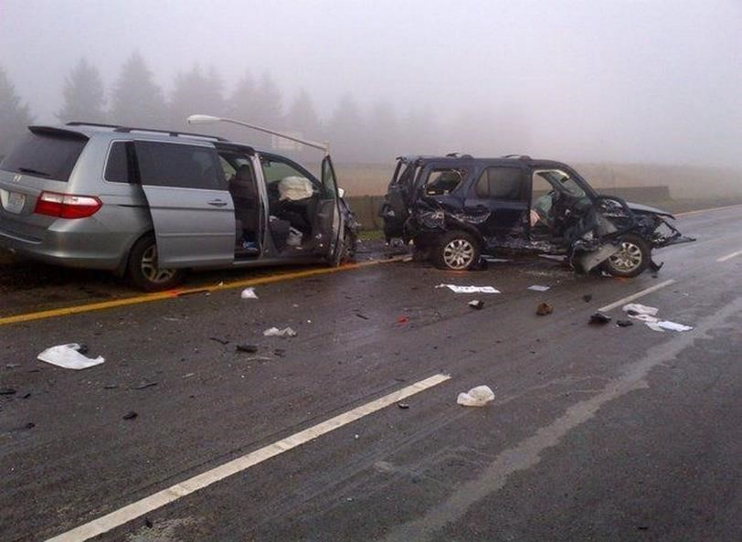

Figure 2.1: Reported accident scene

## GPS Location tracking system

To overcome the challenge of detecting the exactly area where the accident occur the GPS tracking is the good option on locating the area

Below Figure 2.2 show how the GPS tracking system operate to track the location

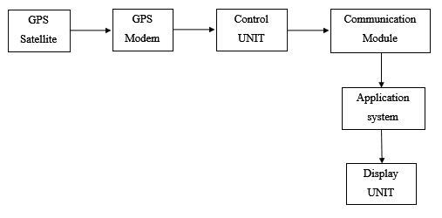

Figure 2.2: GPS Tracking system

## How the system works

This system consists of a GPS satellite, GPS modem, microcontroller, GSM modem, Mobile phone and a Display unit. The system automatically reads the location from the satellite with the GPS modem then sends it to the microcontroller to be processed, then information from microcontroller is sent to the GSM modem where it uses radio technology to send message to the mobile phone indicating latitude and longitude of that area.

Every movement made by the vehicle are noticed so, whenever vehicle seems to be on the same location for a very long-time assumptions made may be either there is accident, or something went wrong in vehicle system. And whenever vehicle changes the route, it might have been robbed.

## Road Accident Information System (RAIS)

This system collects accident information in the country and provide the accident database for decision on road safety. RAIS operation involves the use of accident form sheets for filling accident data. Accident form sheets are filled online from the scene of accident by the traffic, GPS devices are used to collect geo coordinate data of the accident scene then the sheet is sent to all police databases [4].

Figure 2.3 below show accident reporting system mechanism done by RAIS

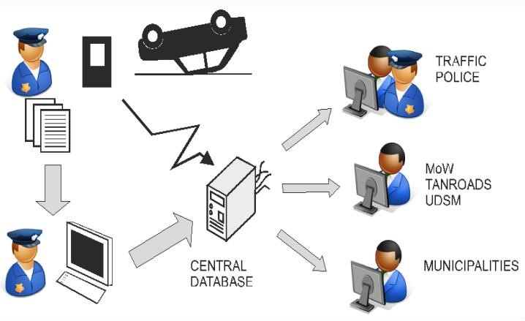

Figure 2.3: Accident reporting through filling of online RAIS sheets.

### Advantages of RAIS

* It is easy and helps to provide information.
* Information reaches to every police station with access to their database

#### Disadvantages of RAIS

* The online sheets can only be accessed with internet connection, but other places do not have internet at all.
* Information cannot reach to the required authority unless someone reports it.
* Some areas have no people’s residents at all and victims might all been injured severely so information delays to reach to the authority.
* GPS provides tracking of all movements made by vehicle but does not give information about accident whenever happens.

## EXISTING SYSTEM

There is system implemented about the car accident detection, though the system seems to lack the accuracy due to missing of Intelligent measure of the accident also the information of the system is sent to the single location regardless with the interval between the accident scene and the reporting station result to the difficult to reach the location.

The system was implemented by Hajra Hussein Adam in 2022 at Dar es salaam institute of technology.

Figure 2.4 show block diagram of the car accident detection and alerting system implemented by Hajra Hussein Adam, 2022

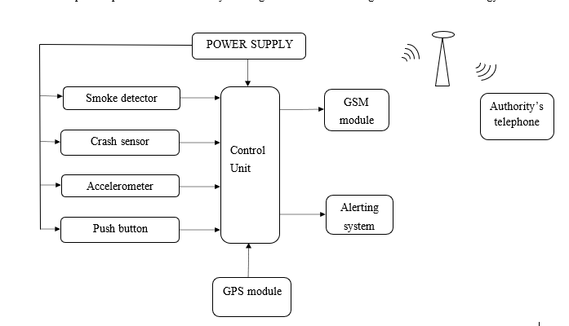

Figure 2.4: Car Accident Locating and Alerting System (By Hajra Hussein Adam, 2022)

### Functionality of the system.

The system will be activated immediately whenever any of the four inputs have been sensed (smoke, crash, falling and insecurity button). If one is sensed then the GPS sends latitude and longitudes of that area to the microcontroller to be processed, then information from control unit is sent to the GSM where, GSM uses a mobile network technology to send message to the required authority. Power supply distributes power to all components within the whole system as per required amount.

### Advantages

It locates the accident location.

### Disadvantages

* It does not store information regarding the accident.
* It is less accurate since, sometimes send wrong accident information.
* It barely saves people’s lives since it sends a text message to just one authority (police) who cannot provide medical assistance.

## Chapter summary

This chapter describes the presence of the problem and different existing systems used to solve the problem. It contains many ideas that has helped to come out with the best and advanced idea that can help to solve this problem.

CHAPTER THREE

# PROPOSED SYSTEM

## Introduction

The system proposed come to solve the challenges faced by the existing system including the Intelligence in accident detection which will help to reduce a number of incorrect information and also the system delocalize the point of receiving information so that the information will reach to the destination which is very close to the accident scene in order to have fast emergence care to the patients.

Figure 3.1 is the block diagram of proposed system.

## Block diagram of proposed system

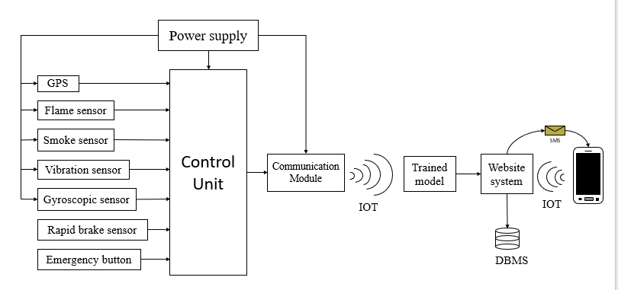

Figure 3.1: Block diagram for proposed system

## Functionality of the proposed system.

The system will be activated immediately whenever any of the inputs have been sensed (flame, smoke, vibration, tilting, rapid break and emergency button). Then the sensed parameter and GPS location are sent using Wi-Fi module to the trained model which is located at the cloud to identify the existence of the accident, If the accident confirmed to be detected by the model, then the notification alert will be popped up to the website to the nearby hospital. If no accident detected by the model the action will be ignored.

At the same time if the accident occur the website application will send automatic SMS to the register numbers of responsible close relative which will show the location where accident occur and the hospital where the patient will be sent together with a link so the he/she can login to the website to see more details.

Flowchart of the proposed system is shown in Figure 3.2 below.

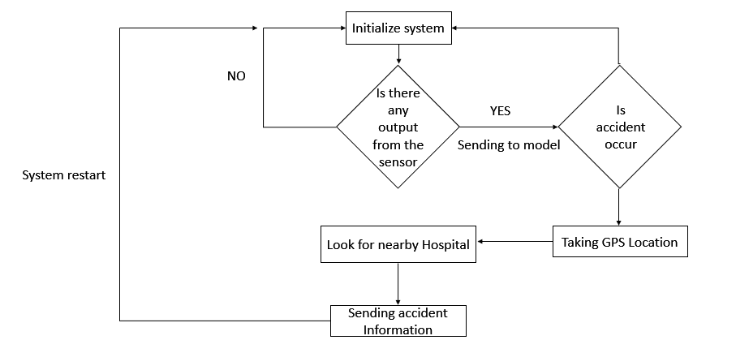

Figure 3.2: Flowchart of the proposed system

## Parts of the proposed system.

The following are explanations for each part of the block diagram of the proposed system.

### Power supply

This is the essential part of the system as it is used to power all components within the system as per need of each block.

### Flame Sensor

This is the type of detector that is used to detect as well as to react to the occurrence of a fire or flame in the vehicle.

### Smoke sensor

This sensor detects smoke indicating presence of fire if anything within the vehicle starts burning then information is sent to the control unit.

### Vibration sensor

This device measures frequency of vibration in a given system. It can detect imbalances and collision between the vehicles.

### Gyroscopic sensor

This sensor measures the angular velocity which is amount of rotation per unit time in degrees per second. It detects tilting of the vehicle.

### Rapid brake sensor

This sensor monitors the wheel’s speed and rotation to optimize both brake and traction control via the Anti-Lock braking system (ABS).

### Button

It is the safety switch to be used which, when activated (on state) the signal is sent to the control unit for further commands.

### Control unit

Includes a micro-controller which integrates all components of the system and make them operate as they are commanded.

### Communication module

This module is responsible for providing network access to the system by enabling sending of information to the database management system and other registered personnel.

### Trained model

This model will have the past experience of how accident is there for by receiving the parameter from the sensor it will determine the occurrence of accident

### Website system

The website will be used to register a new Hospitals and customers to the system together with receiving the accident notification and popping alert

### IoT

The system will communicate wireless with the webservers through Internet to send the accident indicators and other notifications

## Chapter summary

This chapter has described the structure of the proposed system block diagram. It has also explained the general functionality of the proposed system and functions of each block in the proposed system block diagram. Moreover, it has listed the various advantages of the proposed system. The next chapter will contain data collected that verify the problem stated and data that will be used for system design after data analysis

CHAPTER FOUR

# DATA COLLECTION

## Introduction

This chapter concerns with gathering data and information necessary that will be used in the verification of the existence of the problem stated. It also contains informative data concerning the design requirements that will facilitate the design of proposed system. All these data will together facilitate the accomplishment of the project, the data are classified as primary and secondary.

## Primary data

This part includes all the data obtained from the study area to validate the problem through questionnaires, observations, and interviews.

Due to results of the primary data obtained at Tandika taxi station from the driver task is seem that accident that occur 90% has no emergence care to rescuer the injured person and about 95% need automated system to send the information for emergence care.

Table 4.1 show the data results from the questionnaire conducted to taxi drivers there at Tandika mwisho, where by the static graph of this results is shown in Figure 4.1.

Table 4.1: Questionnaire results from 20 taxi drivers at Tandika mwisho station

|  |  |  |  |
| --- | --- | --- | --- |
| Questions | Answers | | |
| **Yes** | **No** | **I don’t know** |
| Have ever seen or being involved in a road accident? | 20 | 0 | 0 |
| If yes was there any emergency care given to the injured? | 5 | 12 | 3 |
| Did health care personnel arrive early to help the injured? | 2 | 17 | 1 |
| Do you think there is a need of a system that automatically sends information about an accident to the nearest hospital? | 18 | 2 | 0 |

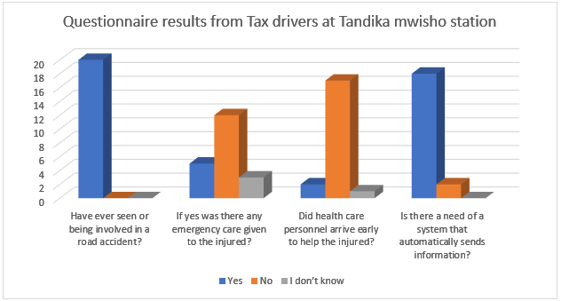

Figure 4.1: Questionnaire results chart

Furthermore, the results obtained by the Interview from AB Hospital show that there are many deaths coursed by the delay of emergence care during the accident.

Table 4.2 below show the Interview results from AB Hospital

Table 4.2: Interview results from AB Hospital

|  |  |  |
| --- | --- | --- |
| **SN** | **Questions** | **Answers** |
| 01 | What is the system you are using now to get information about the patients resulting from the road accidents? | In many cases, the patients are brought by the people from the scene of serious accident, but sometime the phone call information are received from those people. |
| 02 | Do you receive patient or even information of accident at a right time? | Mostly the information delayed and this course the death of patients in many accident cases |
| 03 | What are the challenges you face in receiving information from the patients resulting from road accidents? | * Many people are not willing to give help to the injured persons when accident occur hence information delay and course death sometimes. * Before giving help to the patient of accident PF3 must be received from the Police this scenario course service to delay and sometimes course death to the patients |
| 04 | In average, how many patients do you receive per week? | About 10 to 20 per week |

## Secondary data.

These are technical data that describes the specification of equipment, devices and relevant technology that will be used to build up the proposed system. Data are collected from different sources and internet surfing.

### Power supply

This is the essential part of the system as it is used to power all components within the system as per need of each block.

To accomplish this Table 4.3 below show the requirement of the power supply needed for the system.

Table 4.3: Power supply requirements

|  |  |
| --- | --- |
| **Parameters** | **Requirements** |
| Output voltage | Regulated DC (from 9V to 24V) |
| Re-usability | Must be rechargeable |
| Duration until depleted | Not less than 24 hours |
| Operating temperature | Not more than 60 ̊C |
| Energy capacity | More than 500Wh |

### Control unit.

This is the brain of whole system. It accepts input from smoke sensor, accelerometer, crash sensor and push button process them and produce the output through specified port. It requires a programmable device to be faster and with low power consumption [5].

Table 4.4 show all essential requirements needed for the power supply

Table 4.4: Control unit requirements

|  |  |
| --- | --- |
| **Parameters** | **Requirement** |
| Controller type | Must be programable |
| Program memory | Not less than 32kB |
| Number of GPIO | Not less than 20 pins |
| Operating voltage | Not more than 5V |
| Communication ports | UART, SPI, I2C |
| Operating frequency | Up to 20MHz |
| Power consumption | Low power consumption |

### GPS Module

This module containstiny processors and antennas that directly receive data sent by satellites through dedicated RF frequencies. It reads location in form of latitude and longitude that can be understandable by the reader [6].

Requirement for GPS module are shown in Table 4.5 below.

Table 4.5: Requirements of GPS

|  |  |
| --- | --- |
| **Characteristics** | **Parameters** |
| Operating voltage | 3.3V to 5V DC |
| Information | Location and time |
| Power consumption | Low power consumption |

### Flame sensor

Flame sensor determine the existence of the fire on accident, this will be helpful for prediction of the status of accident.

Table 4.6 below show the requirement for the flame sensor need for the system.

Table 4.6: Flame sensor specification requirements

|  |  |
| --- | --- |
| **Parameter** | **Requirement** |
| Operating voltage | Not more than 5V |
| Power consumption | Low power consumption |
| Operatingtemperature | More than 200 °C |

### Smoke detector

A smoke detector is a device that senses gas example smoke, typically as an indicator of fire.

Smoke detectors issue a signal to a fire alarm control panel.

Smoke sensor requirements shown in Table 4.7 below.

Table 4.7: Gas sensor specification requirements

|  |  |
| --- | --- |
| **Parameter** | **Requirement** |
| Operating voltage | Not more than 5V |
| Power consumption | Low power consumption |
| Operatingtemperature | More than 100 °C |
| Sensitivity | Must be able to detect smoke |

### Vibration sensor

This is an acceleration sensor used to detect if a system has been dropped and is falling, it detects maximum change in orientation of object for-example falling of the vehicle.

Necessary specification for the vibration sensor is shown in Table 4.8 below.

Table 4.8: Vibration sensor specification requirements

|  |  |
| --- | --- |
| **Parameters** | **Requirements** |
| Operating voltage | Not more than 5V |
| Sensitivity | At least 10dB |
| Power consumption | Low power consumption |

### Gyroscopic sensor

This is an acceleration sensor used to detect if a system has been dropped and is falling, it detects maximum change in orientation of object for-example falling of the vehicle.

Gyroscopic sensor must have the specifications are shown in Table 4.9 below.

Table 4.9: Gyroscopic sensor specification requirements

|  |  |
| --- | --- |
| **Parameters** | **Requirements** |
| Operating voltage | Not more than 5V |
| Minimum detecting angle | At least 10 ̊ |
| Power consumption | Low power consumption |
| Sensitivity | Must respond very quick |

### Rapid brake sensor

Rapid brake sensor or crash sensors need to detect a collision and convert it to usable signals within milliseconds. The accelerating forces acting on the sensors after a collision can be as high as a shock.

Table 4.10: Rapid break sensor specification requirements

|  |  |
| --- | --- |
| **Parameters** | **Requirements** |
| Operating voltage | Must be less than 12V |
| Sensitivity | Must be very quick |

### Push button.

Button is used to send a signal to another device to change its state from off to on and vice versa. when activated (on state) the signal is sent to the control unit for further commands. Push button can be pushing to make which switches the device on or push to break which switches the device off.

Table 4.11: Requirements for a push button

|  |  |
| --- | --- |
| **Characteristics** | **Requirements** |
| Type | Normally close or normally open |

### Website and DBMS unit

**Website System**

This is an information system that uses internet web technologies to deliver information and services to user. Website consist of collection of web pages and related content that is identified by a common domain name. The web system for vending machine will have both admin and user interfaces [7].

**DBMS**

This is a software system that is used to store, retrieve and run queries on data. Database in the proposed system will contain collection of information about registered users and through DBMS we will be able to add, delete and update data easily.

Table 4.12 below show the necessary software tools that can accomplish the website system design, Where by the programing languages and framework that can be used is shown in Table 4.13.

Table 4.12: Different databases and webservers available

|  |  |  |  |  |
| --- | --- | --- | --- | --- |
| **Database types** | Relational database | | Non-relational database | |
| **Database systems** | MySQL | Mongo DB | | PostgreSQL |
| **Server** | Infinity free | 000 Webhost | | Heroku |

Table 4.13: Possible programming languages and their frameworks for web application

|  |  |  |  |
| --- | --- | --- | --- |
| **Language** | PHP | JavaScript | Python |
| **Framework** | Laravel, Cake PHP | Node JS, React, Angular JS | Django, Flask, CherryPy |

## Chapter summary.

This chapter contains data that justify the existence of the problem and data collected from various sources. Different components have been analyzed with their desirable features to be used in the designing of the proposed system.

CHAPTER FIVE

# CONCLUSION

This report has explained in details about the proposed system, the problem that motivated the idea, the objectives of the proposed system, the literature reviews and the data collected through interview at AB-hospital and data collected through questionnaires from some taxi drivers at Tandika mwisho, these data aimed to confirm existence of the problem. The report also contains secondary data which are about the technical parameters required for the proposed system. All this information will help in building up the proposed system.

# REFERENCES

|  |  |
| --- | --- |
| [1] | I. report, "Accident reporting system," Incident report, 19 January 2022. [Online]. Available: incidentreport.net. [Accessed 12 January 2023]. |
| [2] | P. A. M. D. A. H. B. D. N. K. S. Parameswaran, "Automatic Vehicle Accident Detection and Messageing System," *International Jounal of Engineering research & technology (IJERT),* vol. 4, no. 11, pp. 1-3, 2016. |
| [3] | M. N. K. Mandeep Kaur Angrula, "Car accident detection and reporting system," *International research Journal of Engineering and Technology (IRJET),* vol. 06, no. 12, pp. 1-3, 2019. |
| [4] | S. Sadanand, "Component selection in Electronics system design". |
| [5] | K. Mackey, "Electronics component selection guidelines," EMA Design Automation, Rocester, New York, 2021. |
| [6] | "OVIO Creative," OVIO Creative, [Online]. Available: oviocreative.com. [Accessed 16 January 2023]. |
| [7] | "SSATP," [Online]. Available: https://www.ssatp.org. [Accessed 3 January 2023]. |

# APPENDICES

## Appendix A

|  |  |  |  |  |  |  |  |  |  |  |  |  |  |  |
| --- | --- | --- | --- | --- | --- | --- | --- | --- | --- | --- | --- | --- | --- | --- |
|  |  |  |  |  | PROJECT DURATION | | | | | |  |  |  |  |
| ACTIVITY | 1 | 2 | 3 | 4 | 5 | 6 | 7 | 8 | 9 | 10 | 11 | 12 | 13 | 14 |
| Project title selection |  |  |  |  |  |  |  |  |  |  |  |  |  |  |
| Title defending |  |  |  |  |  |  |  |  |  |  |  |  |  |  |
| First Min Presentation |  |  |  |  |  |  |  |  |  |  |  |  |  |  |
| Literature review &  Data collection |  |  |  |  |  | | | | | |  |  |  |  |
| Project report  proofreading |  |  |  |  |  |  |  |  |  |  |  |  |  |  |
| Project report  submission |  |  |  |  |  |  |  |  |  |  |  |  |  |  |

## Appendix B

### Questionnaire attachment

### Questionnaire responses

## Appendix C

### Interview attachment.